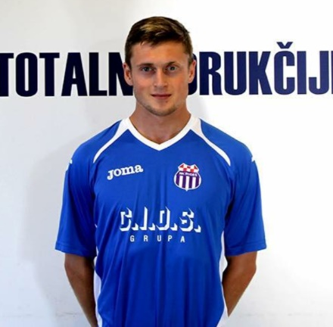
Colin Jacques
colin.jacques22@gmail.com
Cell: (778)-971-6558
Whatsapp: +385 95 526 9088

Bio:
- Date of birth: March 6th, 1994
- Place of birth: Richmond, BC, Canada
- Height: 5’10”/1.78m
- Weight: 155lbs/ 70kg
- Position: Winger/Secondary striker
- Preferred Foot: Right
- Player Status: Free Agent
Previous Teams:
- 2018 NK Istra 1961 Croatian 1st Division
- 2017 NK Rudes Croatian 1st Division
- 2014-2017 NK Rudes Croatian 2nd Division
- 2012-2014 Simon Fraser University NCAA Div 2
Stats:
- NK Rudes (2014-2017):
  - Goals 16
  - Appearances 61
  - Minutes played 4,236
- NK Istra 1961 (2018):
  - Appearances 1
  - Minutes played 26

Highlight Video: https://www.youtube.com/watch?v=0qgK3JRlW6A&t=1s

